|  |  |
| --- | --- |
| Supervisor comments | Comments on corrrection |
| 1. Even though the thesis is generally well-written, additional editing to root out remaining spelling, grammatical and formatting errors is required. The internal examiner has provided a hard copy of the thesis with some errors identified. The candidate is advised to go through the thesis carefully and edit before submission. |  |
| 2. Given the results from the empirical chapters, the first objective of the thesis should be rephrased. The Abstract may need to be reworded to reflect this change. | The original phrasing was misleading as it suggested that I was assessing the global economic burden of diabetes. I have now rephrased this to indicate that the goal is to assess the existing evidence worldwide on the economic burden of diabetes. I did not reword the abstract as it does not make similar claims. (see page 21-22) |
| 3. Chapter 2: The reason for comparing direct and indirect costs should be clarified (e.g., pp. 43-45). In  addition, the role of existing health infrastructure and measurement problems of capturing indirect costs  should be better discussed. | I have now revised the text to better reflect the rationale for the comparison of direct and indirect costs. This also includes a short discussion of measurement issues in the estimation of indirect costs and how health infrastructure can affect the direct cost estimates. (p. 43-44) |
| 4. The discussion about ‘willingness to have treatment’ on p. 68 seems to confound preference  with ability (e.g., a rich person may ‘prefer’ not to take treatment even though s/he is able to do so) | I have deleted the word “willing” to direct focus on those unable to access care due to economic reasons, which is likely to be the biggest problem in low- and middle-income countries. (p. 68) |
| 5a. Chapter 3: Clarify how formal and informal sectors are defined. For example, it is not clear where semisubsistence agriculture is included. It is also good to clarify how employment, wages and hours worked are measured for different sectors. | I have now clarified the definition of formal and informal employment, explicitly stating that semisubsistence agriculture is regarded as informal employment. (page 89)  I assume that you refer to Chapter 4 in the second part of this comment, as I do not investigate the wages and working hours in different sectors in Chapter 3. I decided therefore to address this comment separately under point 5b below. |
| 5b. Chapter 4. It is also good to clarify how employment, wages and hours worked are measured for different sectors. | I have now added the respective information on how employment, wages and working hours were measured for the different sectors to footnotes 3 and 4, which already included some information on the calculation of employment status, wages and working hours. (footnote 4 on p. 101) |
| 6. Chapter 4: Is recall bias really a problem? It is unlikely that people will forget about a diabetes diagnosis since it is a major event. | I agree that recall bias may be only a minor problem. I have deleted the reference to recall bias. I now only state that there are some inconsistencies in the self-reporting of a diabetes diagnosis over time in a small subset of observations that I am addressing to increase consistency. (p. 101) |
| 7. Chapter 5: Include more explanation of marginal structural model. You don’t need to include a technical and long description but just enough to clarify the basic method behind the model. | I have tried to make the use and calculation of the marginal structural model more transparent by changing and improving the structure of the text. (p. 138-141) |
| 8. The assertion that regression-discontinuity design (RDD) models provide results that are only  relevant for observations around the threshold (p. 135) is not necessarily right. This depends on the  distribution below and above the threshold and RDD’s relevance depends on the nature of the  distribution. Hence, it is better to rephrase the statement. | Thank you for that good point. I have revised the text accordingly. (p. 135) |
| 9. Chapter 5: A large data set doesn’t necessarily reduce potential measurement errors; please rephrase  the sentence that implies that on page 136. | Thank you for that comment. The sentence I used was misleading as I did not want to imply that the large data set would help to reduce measurement errors. Rather I was referring to the use of anthropometric measurements of height and weight that the data provide, and that are less prone to measurement error than self-reported height and weight information. I have rephrased the sentence accordingly and hope that it is now clearer. (p. 136) |
| 10. Chapter 5: What proportion of the data set was imputed? What does ‘thirty imputed data sets were  created’ mean (p. 142)? Please clarify. | I have now created a new table displaying the number of missing data that were imputed (see Table A17in the appendix). With ‘thirty imputed data sets were imputed’ I was referring to the number of imputations used, i.e. I used 30 imputations. I acknowledge that the phrasing may have been unfortunate and have now changed it to make it clearer. (p. 144) |
| 11. Chapter 5: In the diagram for the fixed effects model on page 143, the horizontal arrows seem to capture  lagged effects; but standard fixed models do not do that. This should be clarified or the figures should  be changed. | Thank you for picking up this error. I have now revised the figure and deleted the horizontal arrows as they indeed suggested a lagged fixed effects model which I am not estimating. (Figure 9 on p. 143) |
| 12. Chapter 5: The presentation of the figures on pages 151-153 should be arranged to help comparison.  Since the main comparison is between the results from the marginal structural and fixed effects models,  it is better to present the results for each outcomes from the models side-by-side. The interpretation of the graphs should also take the confidence intervals into account; make sure that the confidence intervals  do not cut across the zero line. Also clarify whether these figures are drawn after controlling for other  factors. | Thank you for this comment. I have now rearranged the figures to represent the outcomes from each model side-by-side as suggested. I now present two figures, both providing the results for three outcomes for the three estimation techniques (MSM, FE, RE) side by side. (Figures 10 and 11 on p. 153 and 154)  I have also adjusted my interpretation of the graphs taking better account of the confidence intervals (see p. 150).  The graphs are based on the results on models controlling for other factors. I have now made this clearer in the thesis by adding notes below the figures that refer the reader to the table displaying the results of the model each figure is based on. |
| 13. Chapter 6: The discussion of policy issues and potential policy recommendations is excessively focused  on the health care sector and should be embedded into wider contexts. For example, clarify how the  recommendations and suggestions can be facilitated or constrained by the wider structural problems in  society at large. There needs to be at least a couple of paragraphs outlining the implications of the labour  market findings which suggest that a diabetes diagnosis may lead to employment discrimination.  Although there are other possible explanations for the findings, it is likely that workers in manual  occupations in LMICs newly diagnosed with diabetes may be vulnerable to partial or total loss of income.  Also embed the discussion within the wider disease burden and health infrastructure; note society has  other disease burdens than diabetes and health facilities cater for all ailments. | I have now substantially revised and added to the Discussion section, widening its focus by no also discussing the impact of the overall disease environment (including the double disease burden many middle-income countries face). In particular I discuss how this could constrain efforts to improve diabetes care and prevention, but also point to relationships between diabetes and infectious diseases that could help to integrate diabetes treatment into the existing treatment of infectious diseases, thereby using the existing health infrastructure.  I also discuss the structural problems and the relationship between poverty, infectious and non-communicable diseases that are likely inhibiting efforts from the health system perspective to more successfully prevent and treat diabetes.  Finally, I also mention and discuss the potential for discrimination of people with diabetes in particular in middle-income countries with large informal economies.  (p. 172-175) |

2. Given the results from the empirical chapters, the first objective of the thesis should be rephrased. The Abstract may need to be reworded to reflect this change.

Old text:

*What is the global economic burden of type 2 diabetes, both in terms of costs-of-illness and the labour market effects of diabetes?*

Revised text:

*What is the worldwide evidence of the economic burden of type 2 diabetes, both in terms of COI and the labour market effects of diabetes?*

3. Chapter 2: The reason for comparing direct and indirect costs should be clarified (e.g., pp. 43-45). In addition, the role of existing health infrastructure and measurement problems of capturing indirect costs should be better discussed.

Old text (p. 43):

*To assess the relative importance of direct and indirect costs across countries, we plotted direct against indirect costs from studies that provided both estimates and drew a 45°line depicting the equal share of direct and indirect costs (see Figure 4).*

*Most studies found a larger share for direct costs in comparison with indirect*

*costs (observations above the 45°line in Figure 4). This is especially true for*

*HICs, where only a study on Sweden (Bolin et al., 2009) found a larger share for*

*indirect costs. For LMICs, a study on Colombia (Camilo González et al., 2009)*

*found considerably higher indirect costs, as did the multi-country study of Barceló*

*et al. (2003) and a study on various countries in the African region (Kirigia et al.,*

*2009), which both found higher indirect costs for almost every country in the*

*study and also on average for the entire regions, represented as the mean overall*

*study estimate in Figure 4. Both studies used similar approaches to estimate*

*costs, and indirect cost estimates were likely so high because evidence from only*

*a few countries within the region was used as a basis for estimating indirect costs*

*for every other country in the respective study. Further, the studies took the*

*countries’ per capita gross national product as a proxy for earnings, which might*

*have led to an over-estimation of the indirect costs (Kirigia et al., 2009).*

Revised text:

*To assess the relative importance of direct and indirect costs across countries, we plotted direct against indirect costs from studies that provided both estimates and drew a 45°line depicting the equal share of direct and indirect costs (see Figure 4).*

*Most studies found a larger share for direct costs in comparison with indirect*

*costs. This is especially true for HICs, where only a study on Sweden (Bolin et al.,*

*2009) found a larger share for indirect costs. For LMICs, a study on Colombia*

*(Camilo González et al., 2009) found considerably higher indirect costs, as did*

*the multi-country study of Barceló et al. (2003) and a study on various countries*

*in the African region (Kirigia et al., 2009), which both found higher indirect costs*

*for almost every country in the study and also on average for the entire region,*

*represented as the mean overall study estimate in Figure 4. Both studies used*

*similar approaches to estimate costs, and indirect cost estimates were likely so*

*high because evidence from only a few countries within the region was used as a*

*basis for estimating indirect costs for every other country in the respective study.*

*Further, the studies took the countries’ per capita gross national product as a*

*proxy for earnings, which might have led to an over-estimation of the indirect*

*costs (Kirigia et al., 2009).*

*Overall, no clear pattern emerges that would indicate that in LMICs indirect*

*costs would be higher than direct costs due to their less extensive healthcare sys-*

*tems, or that HICs would be able to prevent indirect costs as a result of their*

*higher healthcare spending. For instance, while some studies indicated that*

*middle-income countries (MICs) such as Colombia and Mexico have higher indi-*

*rect costs, studies on China, Pakistan and, again, Mexico showed the opposite.*

*Difficulties in measuring costs could be one of the main reasons for the hetero-*

*geneity in results even for the same country and may make a comparison of direct*

*and indirect costs difficult. In particular in LMICs countries, direct healthcare*

*expenditures may be low due to limited availability and access to healthcare so*

*that direct costs would be higher if more treatment options were available. Indi-*

*rect costs may also be incorrectly measured, for example the use of the human*

*capital approach—which assumes that productivity losses due to a disease are*

*permanent, even though in reality production losses may only be temporary un-*

*til the employer has found a replacement—may lead to an overestimation of the*

*losses in productivity (Segel, 2006).*

1. Chapter 2: The discussion about ‘willingness to have treatment’ on p. 68 seems to confound preference with ability (e.g., a rich person may ‘prefer’ not to take treatment even though s/he is able to do so).

Old text:

*If possible, the use of convenience samples of people with diabetes visiting a health care institution should be avoided, particularly in LMICs, as it excludes those not able or willing to visit a clinic for treatment due to economic reasons, leaving out a potentially important proportion of diabetes patients.*

Revised text:

*If possible, the use of convenience samples of people with diabetes visiting a health care institution should be avoided, particularly in LMICs, as it excludes those not able to visit a clinic for treatment due to economic reasons, leaving out a potentially important proportion of diabetes patients.*

5a. Chapter 3: Clarify how formal and informal sectors are defined. For example, it is not clear where semisubsistence agriculture is included. It is also good to clarify how employment, wages and hours worked are measured for different sectors.

Old text (p.89):

*To investigate the effect of diabetes on the employment probabilities in the formal and informal labour market, respectively, we estimate separate models with being employed in the formal and informal sector as the respective dependent variables. We define formal employment on the basis of having a written labour contract. Informal employment is defined as working without a written contract or being self-employed.*

Revised text:

*To investigate the effect of diabetes on the employment probabilities in*

*the formal and informal labour market, respectively, we estimate separate*

*models with being employed in the formal and informal sector as the*

*respective dependent variables. We define formal employment on the*

*basis of having a written labour contract. Informal employment is*

*defined as working without a written contract or being self-employed or working in semi-subsistence agriculture.*

5b. Chapter 4: It is also good to clarify how employment, wages and hours worked are measured for different sectors.

Old text:

Footnote 3: *Employment status is defined as having worked or carried out an activity that helped with the household expenses the last week and working for at least four hours per week. This explicitly includes those employed informally, for instance people working in a family business. ... .*

Footnote 4: *...Respondents were also asked for their annual income and we used that information to arrive at an hourly wage if information for monthly labour income was missing. Finally, we adjusted the calculated wage for inflation from the year of the interview up to 2013 and took the log of those values. Due to a considerable number of missing or zero income reports the sample used for the wage estimation is smaller than the sample for working hours. Working hours were calculated summing up the self-reported working hours of the first and—if applicable—the second job*

Revised text:

Footnote 3: *Employment status is defined as having worked or carried out an activity that helped with the household expenses the last week and working for at least four hours per week. This explicitly includes those employed informally, for instance people working in a family business or as peasants on their own land. ...*

Footnote 4: *...Respondents were also asked for their annual income and we used that information to arrive at an hourly wage if information for monthly labour income was missing. Those working self-employed or as a peasant on own land were also asked to provide their monthly and/or annual monetary income. We exclusively used information on monetary income provided in the survey, and consequently do not account for the value of agricultural produce used for the own consumption or the value generated by working in a family business without receiving any monetary remuneration. Finally, we adjusted the calculated wage for inflation from the year of the interview up to 2013 and took the log of those values. Due to a considerable number of missing or zero income reports the sample used for the wage estimation is smaller than the sample for working hours. Working hours were calculated summing up the self-reported working hours of the first and---if applicable---the second job. Working hours were calculated for every type of work, irrespectively of receiving a monetary remuneration or not.*

6. Chapter 4: Is recall bias really a problem? It is unlikely that people will forget about a diabetes diagnosis since it is a major event.

7. Chapter 5: Include more explanation of marginal structural model. You don’t need to include a technical and long description but just enough to clarify the basic method behind the model.

Old text (pages 138-139):

*Marginal structural models*

*MSMs apply inverse probability weights to adjust for confounding and selection*

*bias as a result of time-varying confounders being affected by prior exposure to*

*the treatment (Robins et al., 2000). Under the assumptions of the MSM (Robins*

*et al., 2000)—the reported treatment is the treatment that has actually been*

*received (consistency), there are no unmeasured confounders (exchangeability)*

*and every person in the sample has a non-zero chance of receiving the treatment*

*(positivity) (see the Discussion section for a discussion of the validity of these*

*assumptions in our case)—the causal direct acyclic graph (DAG) shown in Figure*

*8 displays the association between confounders and outcomes and a diabetes*

*diagnosis.*

*In our context it seems possible that, for example, BMI could affect the prob-*

*ability of being diagnosed with diabetes which then itself may affect subsequent*

*BMI levels, confounding the relationship between a diabetes diagnosis and BMI*

*due to non-random selection. Similarly, employment history and current employ-*

*ment could affect the probability of a diabetes diagnosis through their impact on*

*lifestyle and hence diabetes risk factors. For example, an increase in disposable*

*income or a reduction in leisure time as a result of a new job and the subsequent*

*effect on risk behaviours. such as weight gain or higher alcohol consumption,*

*could confound the relationship between a diabetes diagnosis and employment*

*status. MSM accounts for this by calculating inverse probability weights based*

*on the potential risk of a person being diagnosed at each point in time, estimated*

*by logistic regression.*

*To calculate these weights we first construct unstabilized weights using baseline*

*values of time-variant confounders, time-invariant confounders as well as time-*

*variant confounders lagged by one period to predict the probability of developing diabetes at each wave. We use lagged time-variant confounders to make sure that*

*the predictors of diabetes were determined before the current diabetes status, be-*

*cause current diabetes status as reported in the survey was determined at some*

*point between the current and the previous wave. The predictors used are age*

*and age squared to account for changes in risk with increasing age, an index of*

*urbanization pre-constructed within the CHNS data, ranging from 1 to 120 as*

*the level of urbanization increases (Zhang et al., 2014), to account for the impact*

*of urbanization on diabetes risk (Attard et al., 2012). We also use binary vari-*

*ables for secondary and university education, being married, having any medical*

*insurance, being of Han ethnicity, living in a rural area, the different Chinese*

*regions and the respective survey waves as predictors. Moreover, we use infla-*

*tion adjusted per-capita household income to adjust for any effects of household*

*wealth on diabetes. Finally, all outcome variables (employment status, alcohol*

*consumption, smoking status, BMI, waist circumference and average daily calo-*

*rie consumption) are used as predictors. For each wave after the first wave in*

*which each person participated, cumulative probabilities of diabetes were calcu-*

*lated by multiplying the probabilities in the current and all previous waves, thus*

*accounting for each individual’s entire reported history of diabetes risk factors. 5*

*Because unstabilized weights can be highly variable, it is recommended to*

*stabilize the weights (Cole et al., 2008). Using the unstabilized weights as the*

*denominator, stabilized weights are calculated by dividing the denominator by*

*the predicted treatment propensity from a model using only time-invariant con-*

*founders and baseline information of the time-variant confounders as predictors.*

*Because our analysis is stratified by males and females, we create weights sepa-*

*rately for both groups.*

*The MSMs are estimated using OLS for the continuous outcomes and a logis-*

*tic model for the binary outcomes. For the logistic model we calculate average*

*marginal effects for greater comparability with the results of the FE models. All*

*models are weighted by the stabilized weights constructed beforehand while ad-*

*justing for all baseline and time-invariant covariates used in the calculation of the*

*stabilized weights, except for the respective outcome of interest. Robust standard*

*errors to account for intra-class correlation of repeated outcome measurements in*

*individuals are used throughout. In our primary analysis, we present the results*

*of the MSM with untruncated stabilized weights, as these provide theoretically*

*unbiased estimates, albeit they likely are less efficient than truncated weights*

*(Cole et al., 2008). The distribution of the inverse probability weights supports*

*this decision as there are no extreme values and the mean weight is 1 (see Table*

*A17).*

Revised text:

*MSMs apply inverse probability of treatment weightss (IPTWs) to adjust for con-*

*founding and selection bias as a result of time-varying confounders being affected*

*by prior exposure to the treatment (Robins et al., 2000). Under the assumptions*

*of the MSM (Robins et al., 2000)—the reported treatment is the treatment that*

*has actually been received (consistency), there are no unmeasured confounders*

*(exchangeability) and every person in the sample has a non-zero chance of receiv-*

*ing the treatment (positivity) (see the Discussion section for a discussion of the*

*validity of these assumptions in our case)—the causal direct acyclic graph (DAG)*

*shown in Figure 8 displays the association between confounders and outcomes and*

*a diabetes diagnosis.*

*In our context it seems possible that, for example, BMI could affect the prob-*

*ability of being diagnosed with diabetes which then itself may affect subsequent*

*BMI levels, confounding the relationship between a diabetes diagnosis and BMI*

*due to non-random selection. Similarly, employment history and current employ-*

*ment could affect the probability of a diabetes diagnosis through their impact on*

*lifestyle and hence diabetes risk factors. For example, an increase in disposable*

*income or a reduction in leisure time as a result of a new job and the subsequent*

*effect on risk behaviours such as weight gain or higher alcohol consumption, could*

*confound the relationship between a diabetes diagnosis and employment status.*

*MSM accounts for this by calculating inverse probability weights based on the*

*potential risk of a person being diagnosed at each point in time, estimated by*

*logistic regression.*

*For the estimation of MSMs, first unstabilized IPTWs for being diagnosed*

*with diabetes are calculated for each individual at each wave. The IPTWs are*

*proportional to the inverse of the probability of a person having her own observed*

*exposure through that wave and allow the creation of a pseudo population that is*

*exchangeable with the study population within the levels of confounders (Cole et*

*al., 2008). The unstabilized IPTWs are calculated using time-variant confounders*

*measured at baseline, time-variant confounders lagged by one period and time-*

*invariant confounders as right-hand side variables used to predict the cumulative*

*probability of developing diabetes at each wave. We use lagged time-variant*

*confounders to make sure that the predictors of diabetes were determined previous*

*to the manifestation of diabetes. Otherwise, because the diagnosis happened at*

*an unknown point of time between two waves, the key assumption that the time-*

*variant variables used to predict the probability of a diabetes diagnosis are are*

*determined before the diabetes diagnosis may have been violated.*

*The unstabilized IPTWs are calculated using the following predictors: age and*

*age squared to account for changes in risk with increasing age; an index of ur-*

*banization pre-constructed within the CHNS data, ranging from 1 to 120 as the*

*level of urbanization increases (Zhang et al., 2014), to account for the impact of*

*urbanization on diabetes risk (Attard et al., 2012); binary variables for secondary*

*and university education, being married, having any medical insurance, being of*

*Han ethnicity, living in a rural area, the different Chinese regions and the re-*

*spective survey waves; inflation adjusted per-capita household income to adjust*

*for any effects of household wealth on diabetes; and employment status, alcohol*

*consumption, smoking status, BMI, waist circumference and average daily calorie*

*consumption. To create IPTWs that account for each individual’s entire reported*

*history of diabetes risk factors, cumulative probabilities of diabetes were calcu-*

*lated by multiplying the predicted probabilities in the current and all previous*

*waves, for each waver after the baseline wave.5*

*Because unstabilized IPTWs can be highly variable and therefore less precise,*

*it is recommended to stabilize the weights (Cole et al., 2008). To calculate sta-*

*bilized IPTWs, IPTWs are created by predicting the diagnosis of diabetes using*

*only baseline values of time-variant and time-invariant confounders as right-hand*

*side variables. Similar to the calculation of unstabilized IPTWs, cumulative prob-*

*abilities are calculated by multiplying the predicted probabilities in the current*

*and all previous waves, for each waver after the baseline wave. To calculate sta-*

*bilized IPTWs the just created weights are divided by the unstabilized IPTWs.*

*The resulting stabilized IPTWs now only reflect the confounding due to the time-*

*varying covariates, which cannot be appropriately adjusted for by standard re-*

*gression models (Cole et al., 2008). Because our analysis is stratified by males*

*and females, we create separate weights for each gender.*

*The MSMs for any of the outcome variables are then estimated adjusting for any*

*baseline and time-invariant confounders used in the calculation of the IPTWs, ex-*

*cept for the respective outcome of interest, and weighted by the stabilized IPTWs*

*to adjust for time-variant confounding. OLS regression models were used for*

*continuous outcomes (BMI, waist circumference and calorie consumption) and a*

*logistic model for the binary outcomes (employment status, smoking status and*

*alcohol consumption). For the logistic model we calculate average marginal effects*

*for greater comparability with the results of the FE models. Robust standard er-*

*rors to account for intra-class correlation of repeated outcome measurements in*

*individuals are used throughout. In our primary analysis, we present the results*

*of the MSM with untruncated stabilized weights, as these provide theoretically*

*unbiased estimates, albeit they may be less efficient than truncated weights if the*

*IPTWs have a wide range considerably diverting from 1 (Cole et al., 2008). Given*

*that our IPTWs do not include very extreme values and have a mean weight of*

*1 (see Table A17), using untruncated weights likely leads to very little loss in*

*efficiency in our case, supporting the decision to use untruncated weights in our*

*primary analysis.*

8. Chapter 5:

The assertion that regression-discontinuity design (RDD) models provide results that are only relevant for observations around the threshold (p. 135) is not necessarily right. This depends on the distribution below and above the threshold and RDD’s relevance depends on the nature of the distribution. Hence, it is better to rephrase the statement.

Old text:

*Further, the results may have limited generalisability, since the measured treatment effect was a very local one, applying only to the population around the hypertension threshold.*

Revised text:

*Further, the results may have limited generalisability, since the measured treatment effect may have been a very local one, depending on the representativeness of the population distribution below and above the threshold of the overall population above the threshold. In the case of significant differences between the populations, the results would only be applicable to the population around the hypertension threshold.*

9. Chapter 5: A large data set doesn’t necessarily reduce potential measurement errors; please rephrase the sentence that implies that on page 136.

Old text:

*The data provide extensive information on nutrition and health, including anthropometric measures of weight and height, reducing potential measurement issues.*

Revised text:

*The data provide extensive information on nutrition and health. Importantly this includes anthropometric measures of weight and height that reduce potential measurement issues plaguing self-reported data.*

10. Chapter 5: What proportion of the data set was imputed? What does ‘thirty imputed data sets were created’ mean (p. 142)? Please clarify.

Old text (p. 142):

*Multiple imputation*

*To avoid excluding participants with missing data on one or more variables, we*

*used chained multiple imputation to impute the missing values in Stata 13 us-*

*ing the user written ICE command (Royston et al., 2009). Overall, thirty im-*

*puted datasets were created. Imputation models included all variables used in*

*the MSMs. We imputed missing data in the same wave for which some data were*

*recorded; we did not impute completely missing waves. Further, we assumed that*

*once a diabetes diagnosis was reported, the individual had diabetes in every ensu-*

*ing wave, even when the observation was missing. If diabetes was never reported*

*in any wave, we assumed that the individual never had diabetes. We then only*

*imputed missing values for those observations that had a non-missing diabetes*

*status. For the calculation of the marginal effects in the MSM logit models, Ru-*

*bin’s rules were applied using the user written Stata command mimrgns (Klein,*

1. *.*

Revised text (p.144):

*Multiple imputation*

*To avoid excluding participants with missing data on one or more variables, we*

*used chained multiple imputation to impute the missing values in Stata 13 using*

*the user written ICE command (Royston et al., 2009). For most of the included*

*variables, less than 10 percent of the observations was missing. Only the an-*

*thropometric measures of BMI and waist circumference had both about thirteen*

*percent missing data which had to be imputed (see Table A17 in the appendix*

*for detailed information on the number of missing observations). In total—before*

*imputation—close to 20 percent of all cases were incomplete, i.e. had at least one*

*variable that had missing data. Therefore thirty imputations were performed to*

*ensure efficiency and correct standard errors. This is well above the commonly*

*suggested rule of thumb that the number of imputations should be similar to the*

*percentage of incomplete cases in the data (see for example Bodner (2008) and*

*White et al. (2011) for practical suggestions regarding the optimal number of*

*imputations). Imputation models included all variables used in the MSMs. We*

*imputed missing data in the same wave for which some data were recorded; we*

*did not impute completely missing waves. Further, we assumed that once a dia-*

*betes diagnosis was reported, the individual had diabetes in every ensuing wave,*

*even when the observation was missing. If diabetes was never reported in any*

*wave, we assumed that the individual never had diabetes. We then only imputed*

*missing values for those observations that had a non-missing diabetes status. For*

*the calculation of the marginal effects in the MSM logit models, Rubin’s rules*

*were applied using the user written Stata command mimrgns (Klein, 2014).*

1. Chapter 5: In the diagram for the fixed effects model on page 143, the horizontal arrows seem to capture lagged effects; but standard fixed models do not do that. This should be clarified or the figures should be changed.

Old figure:

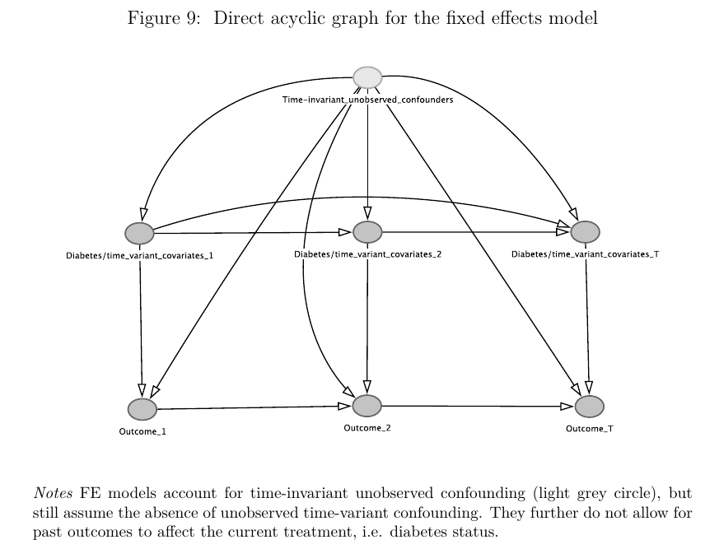

Revised figure:

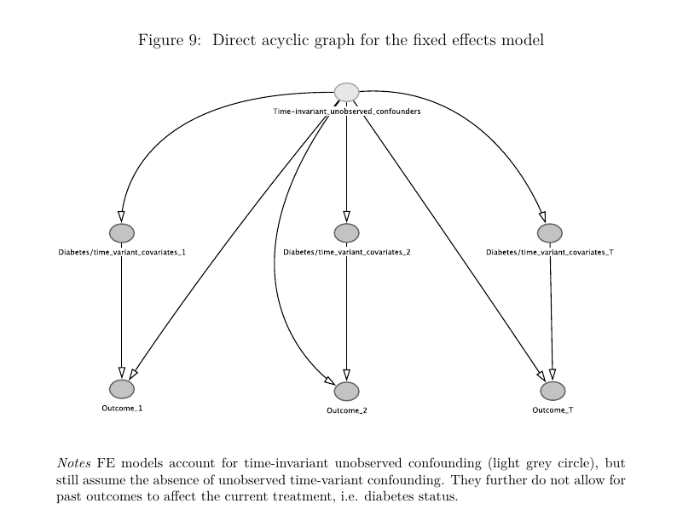

1. Chapter 5: The presentation of the figures on pages 151-153 should be arranged to help comparison. Since the main comparison is between the results from the marginal structural and fixed effects models,it is better to present the results for each outcomes from the models side-by-side.

Old figures:

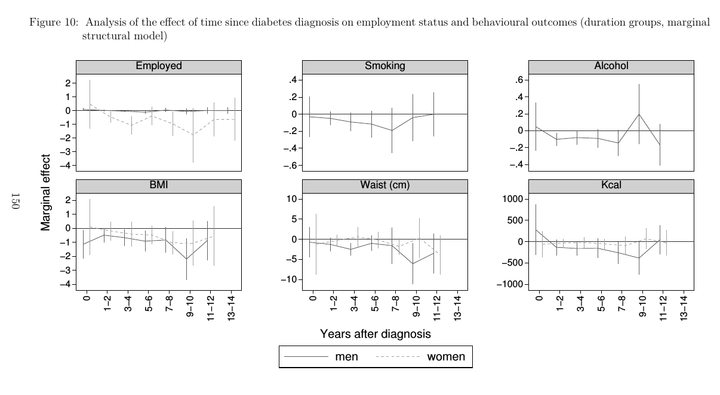

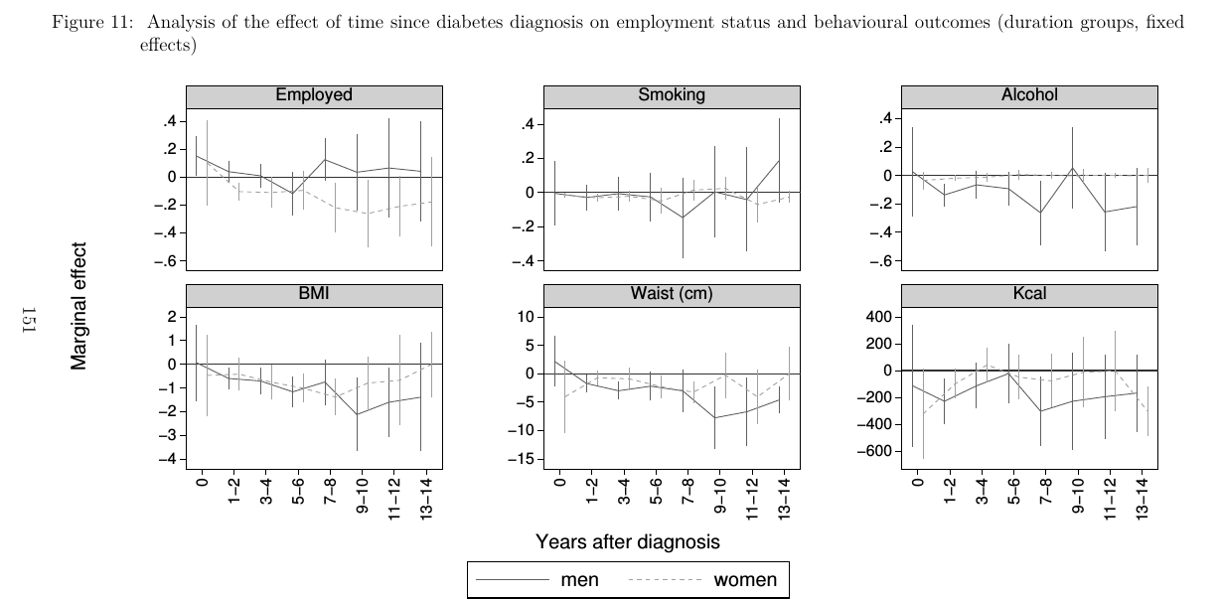

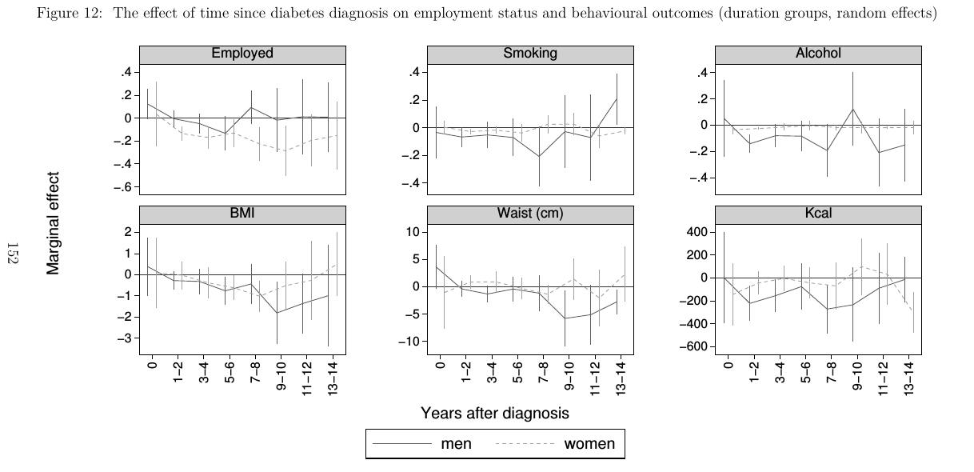

New figures:

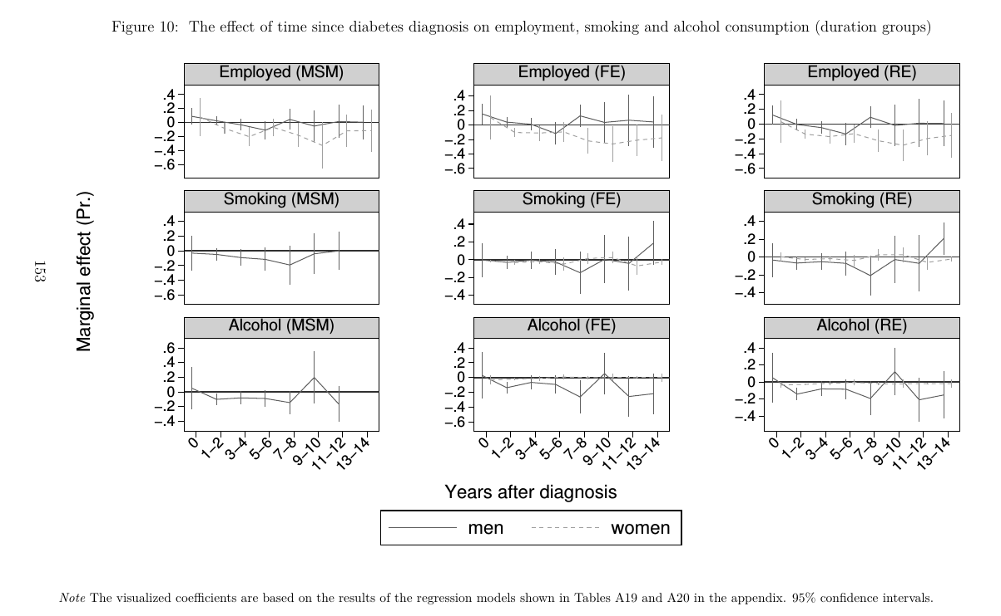

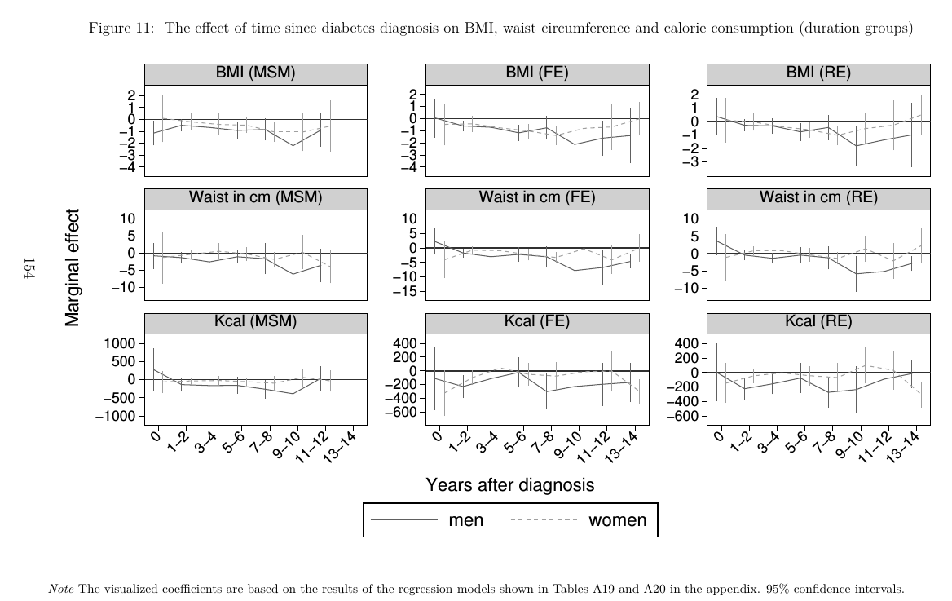

1. The interpretation of the graphs should also take the confidence intervals into account; make sure that the confidence intervals do not cut across the zero line. Also clarify whether these figures are drawn after controlling for other factors.

Old text (referring to the interpretation of the graphs):

*In a second step we estimate a specification using year dummies to capture*

*the potential non-linearity in the relationship between time since diagnosis and*

*our outcomes. The results for the different estimation methods are visualized in*

*Figures 10, 11 and 12 and presented in Tables A18, A19 and A20 in the appendix*

*for the MSM, FE and RE model, respectively. The MSM model still indicates a*

*reduction in female employment probabilities and male BMI, waist circumference*

*and calorie consumption as well as smoking and alcohol consumption, especially*

*in the first 8 to 10 years after diagnosis. Behavioural risk factors for women*

*are again not found to be reduced consistently, apart from BMI where some*

*trend towards a reduction over time is visible. Interestingly, female employment*

*already decreases rapidly in the first to second year after diagnosis and it does*

*not appear that females are able to increase their employment probabilities later*

*on. Unfortunately it was not possible to estimate the effects on female smoking*

*and alcohol consumption due to the low prevalence of these risk factors in females*

*and the lower sample size in the MSM. Using the FE model, all point estimates*

*indicate similar effects. The RE model, again suggests larger effects on female*

*employment and lower effects on BMI and waist circumference than both other*

*estimation methods.*

Revised text:

*In a second step we estimate a specification using year dummies to capture*

*the potential non-linearity in the relationship between time since diagnosis and*

*our outcomes. The results for the different estimation methods are visualized in*

*Figures 10 and 11 and presented in Tables A19, A20 and A21 in the appendix*

*for the MSM, FE and RE model, respectively. The MSM and FE model indicate*

*a statistically significant reduction in female employment probabilities in the*

*first eight years after diagnosis, with the exception of the fifth and sixth year,*

*where the effects are not statistically significant. Further, male BMI and waist*

*circumference are also reduced significantly in most years especially in the FE*

*models which finds significant effects in the first six years after diagnosis and*

*then in years nine to twelve. The MSM model still indicates reductions but these*

*tend to be less statically significant. Calorie consumption is not found to be*

*statistically significantly reduced in a consistent manner neither in the MSM or*

*the FE model. Behavioural risk factors for women are again not found to be*

*reduced consistently, apart from BMI where some trend towards a reduction over*

*time is visible. Interestingly, female employment already decreases rapidly in the*

*first to second year after diagnosis and it does not appear that females are able*

*to increase their employment probabilities later on. Unfortunately it was not*

*possible to estimate the effects on female smoking and alcohol consumption due*

*to the low prevalence of these risk factors in females and the lower sample size in*

*the MSM. Using the FE model, all point estimates indicate similar effects. The*

*RE model, again suggests larger effects on female employment and lower effects*

*on BMI and waist circumference than both other estimation methods.*

Chapter 6: The discussion of policy issues and potential policy recommendations is excessively focused on the health care sector and should be embedded into wider contexts. For example, clarify how the recommendations and suggestions can be facilitated or constrained by the wider structural problems in society at large. There needs to be at least a couple of paragraphs outlining the implications of the labour market findings which suggest that a diabetes diagnosis may lead to employment discrimination.

Although there are other possible explanations for the findings, it is likely that workers in manual occupations in LMICs newly diagnosed with diabetes may be vulnerable to partial or total loss of income.

Also embed the discussion within the wider disease burden and health infrastructure; note society has other disease burdens than diabetes and health facilities cater for all ailments.

Old text:

Only little changes that are better visible by looking at the tracked changes document.

Additional text:

***Communicable diseases and structural constraints***

*The mentioned strategies may be able to reduce the diabetes, however, they*

*mostly focus on diabetes only and do not take into account potential possibilities*

*for the integration of treatment with other diseases common among the poor,*

*nor do these interventions address overall structural problems responsible for the*

*inequities in the burden of diabetes. They therefore tend to represent tempo-*

*ral solutions aiming to address specific needs of people at risk of or living with*

*diabetes under current circumstances, but may not help to substantially reduce*

*the burden of diabetes in the long term if structural constraints existent in most*

*MICs are not taken into account.*

*A first constraint to the successful implementation of above mentioned inter-*

*ventions is the wider disease burden, which may inhibit the healthcare system*

*from providing effective treatment for diabetes and other chronic diseases. How-*

*ever, integrating diabetes care with the healthcare for other diseases may also*

*present a viable opportunity for healthcare systems in MICs.*

*Health systems in developing countries have been slow to adopt technologies to*

*reduce the burden of communicable diseases, maternal and perinatal conditions*

*as well as nutritional deficiencies (Gutiérrez-delgado et al., 2009). The main rea-*

*sons for this slow adoption are social and political instability limiting long-term*

*planning, a lack of resources to finance the introduction of health technologies,*

*and a dearth of qualified personnel in the public sector due to a lack of training*

*and the loss of qualified personal to the private sector or health systems in de-*

*veloped countries (Gutiérrez-delgado et al., 2009). Therefore many MICs face a*

*double disease burden with high rates of communicable and non-communicable*

*diseases at the same time (Gutiérrez-delgado et al., 2009). The treatment of*

*non-communicable diseases (NCDs) places additional pressure on health systems*

*that did mainly developed to provide acute care of infectious diseases based on*

*single-visit treatments and are lacking the infrastructure, resources and experi-*

*ence for the treatment of chronic diseases such as diabetes (Nulu, 2016). Policy*

*makers in MICs therefore are forced to make decisions about the prioritization of*

*treatments in an effort to use the available resources in a cost-effective as well as*

*equitable manner (Gutiérrez-delgado et al., 2009), potentially limiting a systems*

*ability to provide effective diabetes care.*

*To improve treatment for diabetes under these circumstances, a greater inte-*

*gration of health services and control efforts of diabetes with the treatment of*

*communicable diseases could help to exploit synergies and interactions between*

*diabetes and communicable diseases. One such example presents the known re-*

*lationship of diabetes with tuberculosis, where diabetes patients have a two-*

*to threefold higher risk to develop tuberculosis. Further, tuberculosis may also*

*complicate glucose management in people with diabetes (Dooley et al., 2009).*

*Therefore, instead of competing for resources, the detection and treatment of*

*both diseases may be integrated to reduce costs and improve health outcomes*

*(Marais et al., 2013). Because tuberculosis and other communicable diseases*

*are more common in groups of lower socioeconomic status with less access high*

*quality care, the double burden with diabetes and the interplay between the dis-*

*eases has the potential to even further increase the already existing health and*

*social inequities (Marais et al., 2013). Therefore, focusing on ways to take ad-*

*vantage of the synergies presenting themselves in the treatment of communicable*

*and non-communicable diseases could provide a way to reduce the overall disease*

*burden, in particular of more marginalized populations, which could also reduce*

*the existing inequities while limiting the strain on healthcare budgets.*

*Additionally, studies have consistently shown a relationship of early life health*

*with later life health outcomes, suggesting that bad health and nutritional status*

*early in life could increase the risk to develop diabetes and other diseases later*

*(Currie et al., 2013; Hanson et al., 2012). Therefore, efforts to improve maternal*

*and early life health outcomes of children will not only have short-term effects*

*but likely help to prevent adverse health outcomes later in life (Bygbjerg, 2012;*

*Marais et al., 2013). As a result, investing in the treatment of infectious diseases,*

*nutritional deficiencies and maternal health could help to reduce the overall dis-*

*ease burden now and in the future. Further, because again it is the poor that*

*are likely most exposed to the risk of adverse early life events, such efforts would*

*likely help to reduce the economic inequities found in this thesis.*

*However, while a grater integration of diabetes care with the care of other*

*diseases may be a viable way forward, these changes in the formal health-care*

*sectors will not be sufficient. Because of the feedback loops between poverty and*

*bad health, i.e. poor people are more likely to be sick which then further worsens*

*their economic situation, socioeconomic inequities themselves are drivers of the*

*disease burden (Di Cesare et al., 2013). Consequently, structural problems such as*

*an unequal distribution of power, financial resources, education, the environment,*

*housing as well as access to high quality health care, need to be addressed. Only*

*this will help to achieve lasting reductions in inequalities and consequently also*

*the disease burden due to both communicable and non-communicable diseases*

*(Di Cesare et al., 2013).*

***Discrimination of people with diabetes***

*Despite the proposed efforts to reduce inequities in the burden of diabetes, peo-*

*ple with diabetes may still face discrimination. The thesis has found considerable*

*adverse effects of diabetes on employment chances which may not only be ex-*

*plained by its health impact, but also by employers discriminating against people*

*with the disease. Once employers are aware of the employee’s diabetes, they may*

*decide to replace the employee with a healthy person as they suspect reductions*

*in productivity due to health problems or disease management at the workplace.*

*Little information exists regarding the importance of discrimination of employers*

*against people with diabetes in LMICs. For the USA, studies show that people*

*with diabetes were more likely to experience discharge, constructive discharge*

*or suspensions affecting their ability to retain their job (McMahon et al., 2005).*

*Further, working for smaller employers, being older and the ethnic background*

*affected the risk of experiencing discrimination due to diabetes in the workplace.*

*Similarly, a study for Switzerland found that people with diabetes were less likely*

*to be hired and diabetes related events—such as hypoglycemia—made it more*

*likely to experience job loss (Nebiker-Pedrotti et al., 2009). Even though we have*

*no information about the importance of discrimination for the employment ef-*

*fects found in this thesis, given the evidence from HICs it is likely that it plays*

*a considerable role. The adverse effects for the poor and informally employed*

*found in this thesis suggest that discrimination may play a more important role*

*in manual occupations that value physical health to a greater extent than more*

*brain based jobs in the formal sector. Additionally, informal jobs are not af-*

*fected by job security legislation (Loayza et al., 2011; Ulyssea, 2010), reducing*

*the costs of hiring and training a new employee, making it easier to replace a ’un-*

*healthy’ with a ’healthy’ employee, further incentivising discrimination against*

*people with diabetes.*

*Unfortunately, simple remedies for this type of discrimination are difficult in*

*MICs. Because informal labour markets are a substantial part of transition*

*economies, legislative measures to reduce the incentives of discriminating against*

*people with diabetes may fall short—at least partly—as they would not be en-*

*forceable in the informal sector. Further, stricter protection legislation may have*

*counterproductive effects in middle-income countries if they lead to reduced hir-*

*ings of people with diabetes or those at a higher risk to develop diabetes, such as*

*overweight or obese candidates (Muravyev, 2014). Companies may be inclined to*

*demand health check-ups prior to hiring to prevent the employment of personal*

*with a higher risk of adverse health outcomes. Therefore measures to reduce*

*discriminatory behaviour in employers in MICs should also aim at reducing prej-*

*udices about people with diabetes, increase the knowledge about the treatment*

*of the condition and the potential to prevent its adverse health consequences.*

*Overall it seems that for MICs, national policies to change food consumption*

*behaviours to prevent diabetes could currently be the best option to halt the es-*

*calation of the economic impact of diabetes and to reduce inequities. The results*

*of this thesis suggest that it should be a priority to design interventions that*

*address the existent inequities by preventing diabetes in those populations that*

*experience the worst economic consequences, i.e. the poor and more marginalised*

*groups of a country. One way to reduce the existing inequities using the existing*

*health care system would be the integration of the treatment of diabetes with al-*

*ready existing strategies to treat related communicable diseases, common among*

*underserved populations. This would also reduce competition for resources to*

*treat different diseases, a problem facing many decision makers in very resource*

*constrained healthcare systems. The evidence base for the effectiveness of screen-*

*ing programs, preventative pharmacological treatment and lifestyle interventions*

*is less conclusive, potentially due to the social and economic structural constraints*

*existent in many MICs, preventing their successful implementation. Therefore,*

*the structural problems underlying the already existing social, economic as well*

*as health inequities will need to be addressed to achieve long term reductions in*

*the burden of diabetes. This also pertains to issues of discrimination of people*

*with diabetes at the workplace, currently being mostly unprotected from such*

*behaviour due to the large informal labour markets in MICs.*